**Quiz 2**

Name: Ahmed Salah Ahmed Section: 1

**Answer**:

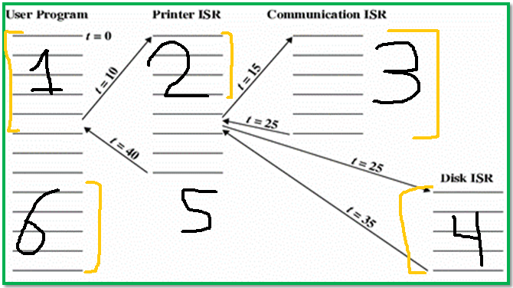

**The time for each process is:**

**1- Time for User Program 🡪 t=10**

**2- Time for Printer ISR 🡪 t=10**

**3- Time for Communication ISR 🡪 t=10**

**4- Time for Disk ISR 🡪 t=10**